COSI-Measure v1.0
Mechanical Assembly

Revision History
Rev. | Date  (YYYY-MM-DD) | Description of Change | Author/  Contributors
1.0 | 2017-08-29 | Initial version | Haopeng Han  Lukas Winter
1.1 | 2018-08-24 | Revised version | Lukas Winter

Notes:

ABOUT
Please find below the documentation to assemble the mechanical components of COSI measure a 3D multipurpose measurement system [1]. If you find any flaws or if you have any questions/suggestions with regards to this document or project please let us know lukas.winter@ptb.de. Improving the quality of this work and its documentation makes it easier for others to reproduce and build upon this work.

Documentation published describing Hardware is licensed under the CERN OHL v. 1.2. You may redistribute and modify this documentation under the terms of the CERN OHL v.1.2. (http://ohwr.org/cernohl) except otherwise stated.

This documentation is distributed WITHOUT ANY EXPRESS OR IMPLIED WARRANTY, INCLUDING OF MERCHANTABILITY, SATISFACTORY QUALITY AND FITNESS FOR A PARTICULAR PURPOSE. Please see the CERN OHL v.1.2 for applicable conditions.

If you find COSI measure useful in your work, please cite this paper:
[1] Han H, Moritz R, Oberacker E, Waiczies H, Niendorf T and Winter L, „Open Source 3D Multipurpose Measurement System with Submillimetre Fidelity and First Application in Magnetic Resonance“, Scientific Reports, 7:13452, 2017
Introduction
This document describes the mechanical assembly of COSI Measure. The partlist can be found in the bill of material (BoM) v1.1 file.
A more detailed description of COSI Measure can be found here: http://www.opensourceimaging.org/project/cosi-measure/
and here:
Han H, Moritz R, Oberacker E, Waiczies H, Niendorf T and Winter L, „Open Source 3D Multipurpose Measurement System with Submillimetre Fidelity and First Application in Magnetic Resonance“, Scientific Reports, 7:13452, 2017

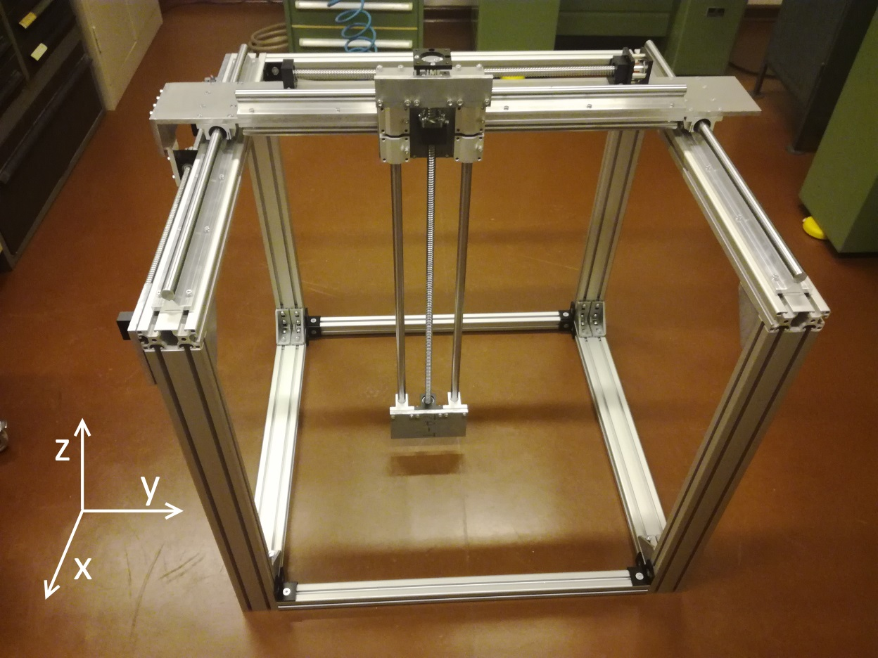Figure 1: Final mechanical setup of COSI Measure
Mechanical assembly of COSI Measure

Required tools:
- Socket screw keys for M5, M6, M8

- Step

Components needed:
Quantitiy | Part description | Number (BoM) | Comment
6 | Aluminum Frames (40x80x800)mm³ | 1
8 | Angles, 40x80 | 2
36 | Slot nuts, M8 | 2 & 4
32 | Screws, M8x18 | 2

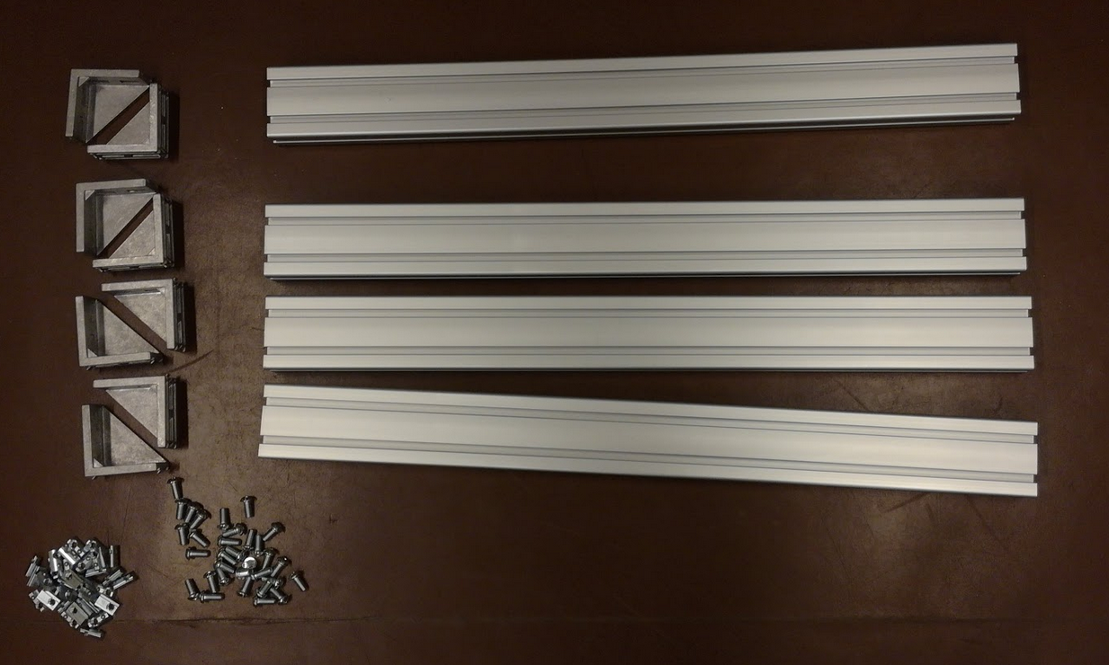Figure 2: Components needed for this assembly step

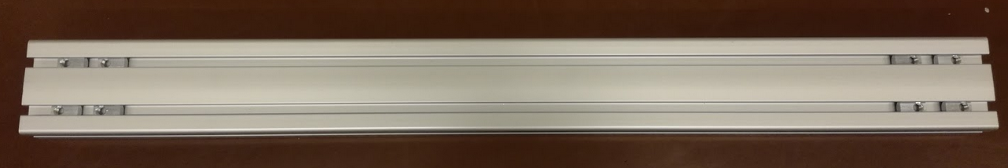Figure 3: Slot nuts inserted in aluminum frame
  - Take two aluminum frames and insert 4 slot nuts at each end of the frames (Figure 3).
  - Add an additional slot nut in the perpendicular part of the frame (Figure 4).
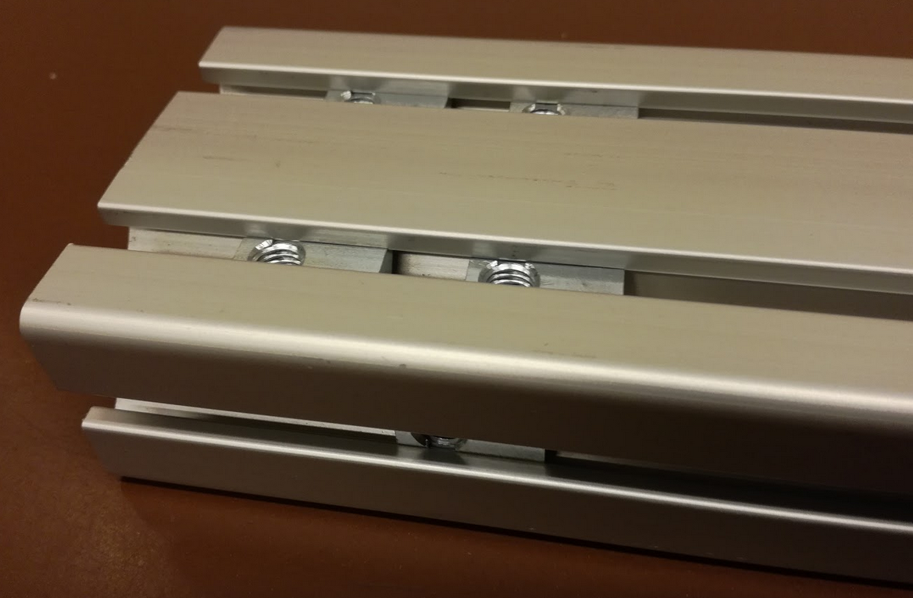Figure 4: Note the inserted slot nut at the bottom
  - Fix the angles to these two aluminum frames using the screws.
  - Insert 4 slot nuts at the top of one end of the remaining 4 frames (Figure 5).
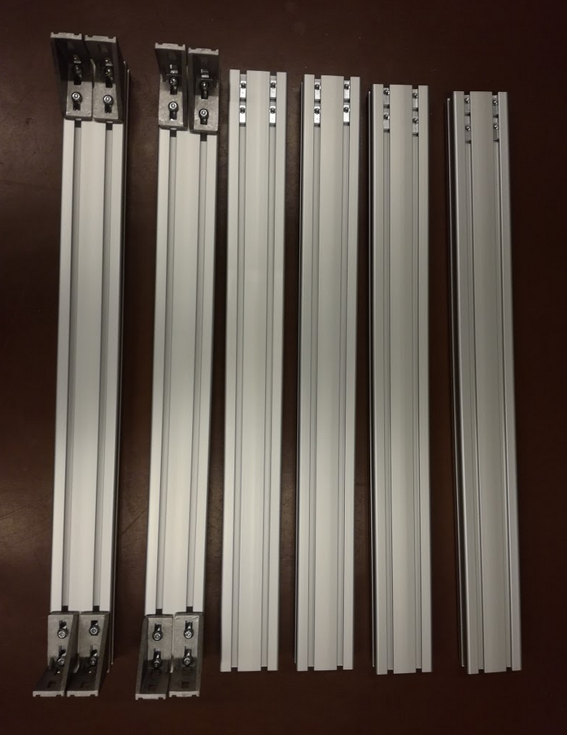Figure 5: Assembled structure after step 1.4

  - Screw remaining frames to the angles (Figure 6).
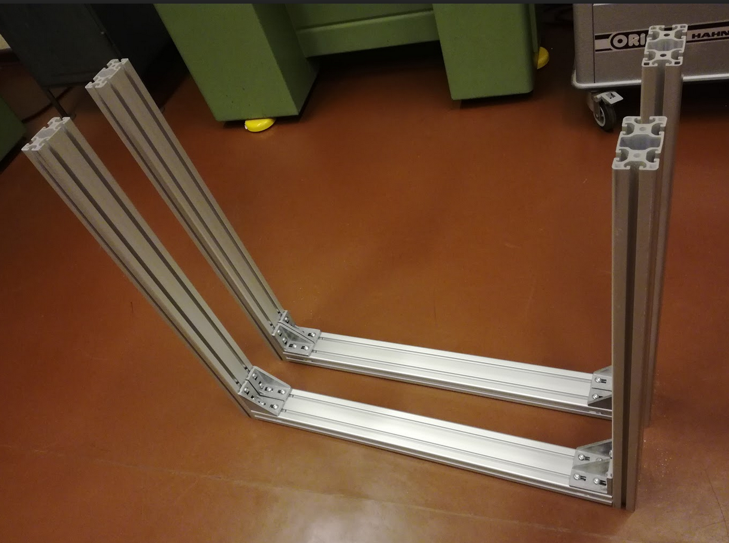Figure 6: Assembly after completing step 1

- Step

Components needed:
Quantitiy | Part description | Number (BoM) | Comment
2 | Aluminum Frames (40x40x800)mm³ | 3
8 | Angles, 40 | 4
12 | Slot nuts, M8 | 4
16 | Screws, M8x18, countersunk | 4

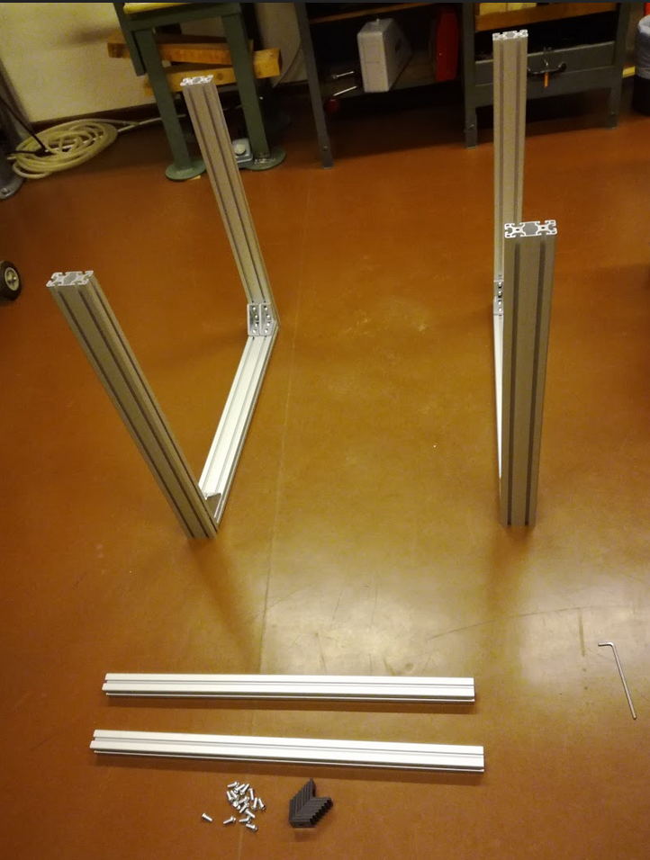Figure 7: Preparing assembly step 2

  - Insert the slot nuts into the aluminum frame (2 on each side of each frame, Figure 8).
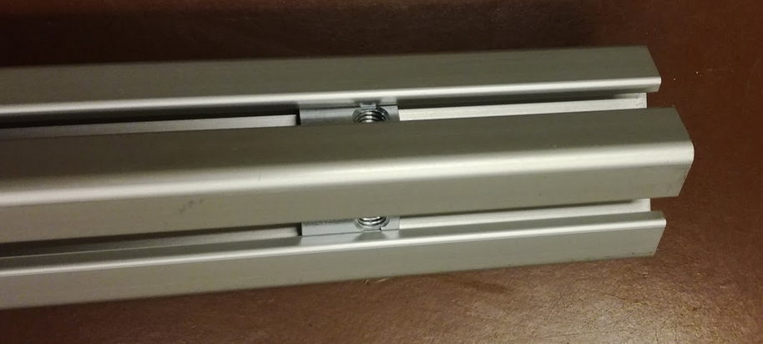Figure 8: Inserted slot nuts at each end

  - Insert a slot nut at each corner into the vertical aluminum frame (40x80) as seen in Figure 7. These slot nuts will be used to connect the structure from step 1 with the 40x40 frames used in this step.
  - Screw the two aluminum frames (40x40)mm² to the structure from step 2 using the angles as seen in Figure 9.
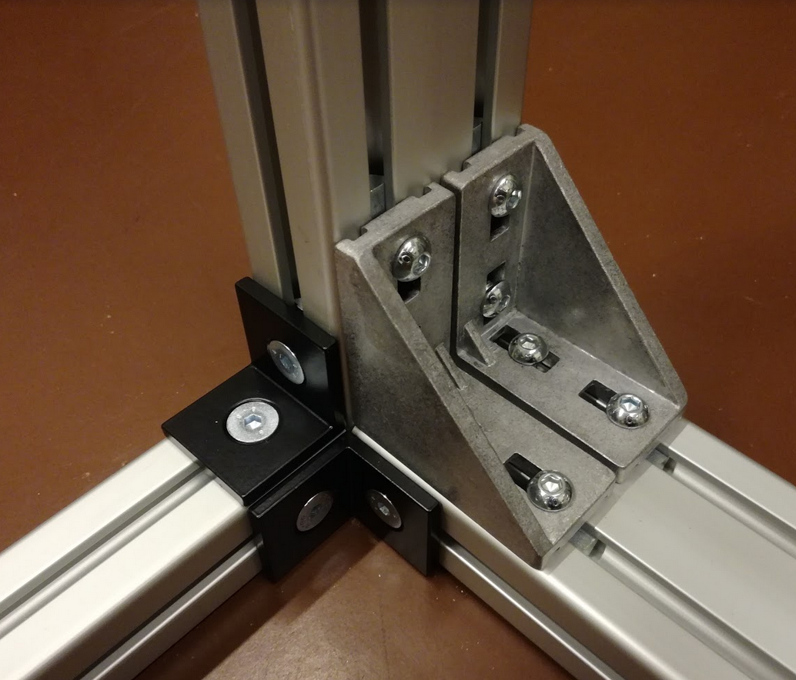Figure 9: Connecting aluminum frames 40x40 and 40x80

- Step

Components needed:
Quantitiy | Part description | Number (BoM) | Comment
18 | Slot nuts, M8 | 2 & 4

  - Insert 5 slot nuts at the top of two frames of the standing structure (Figure 10, Figure 12) and 4 slot nuts at the top of the remaining two frames of the standing structure (Figure 11, Figure 12). These slot nuts will be used to attach angles later on.
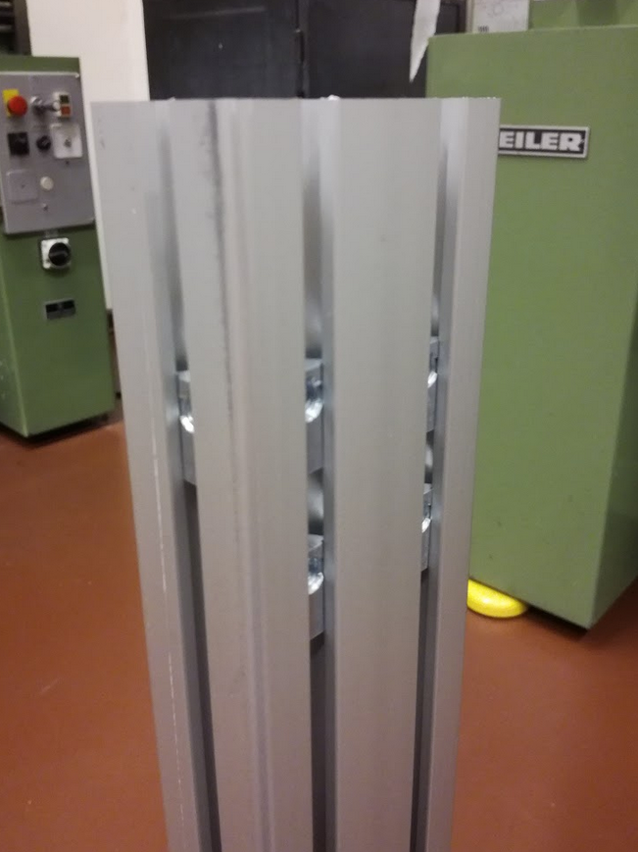Figure 10: “Left” side 5 slot nuts
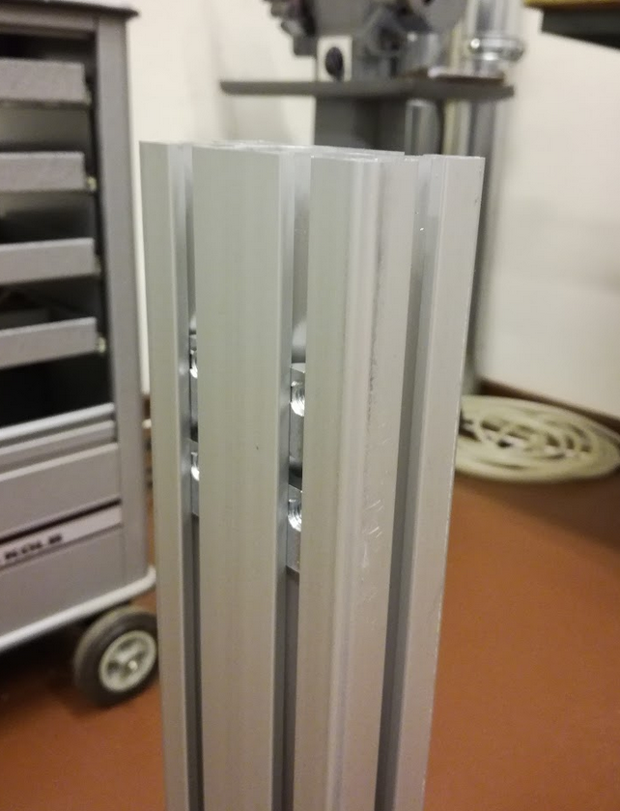Figure 11: “Right” side 4 slot nuts
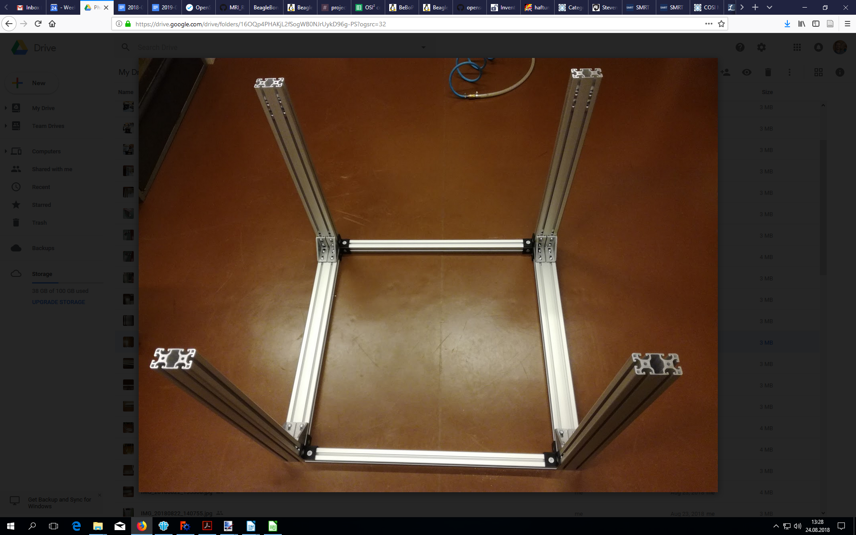Figure 12: Finished structure after step 3

- Step

Components needed:
Quantitiy | Part description | Number (BoM) | Comment
18 | Slot nuts, M8 | 2 & 4
2 | Aluminum frames, (40x80x880)mm² | 5
8 | Angles, 40x80 | 2
32 | Screws, M8x18 | 2

  - Insert 5 slot nuts at one end and 4 slot nuts at the other end of each aluminum frame.
  - Attach the angles to these aluminum frames (Figure 13).
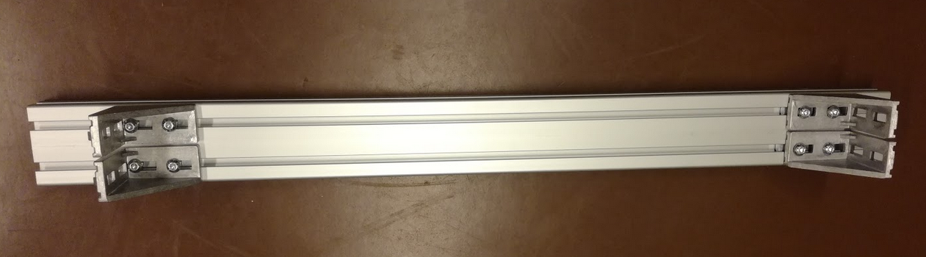Figure 13: Angle attached to the 880mm long aluminum frames.
  - Now position the 880mm aluminum frame on top of the standing structure and connect the angles as seen in Figure 14&15. Please note that there are two slot nuts on the left side (not on right). These will be used in the next step to connect the only remaining aluminum frame 40x40.

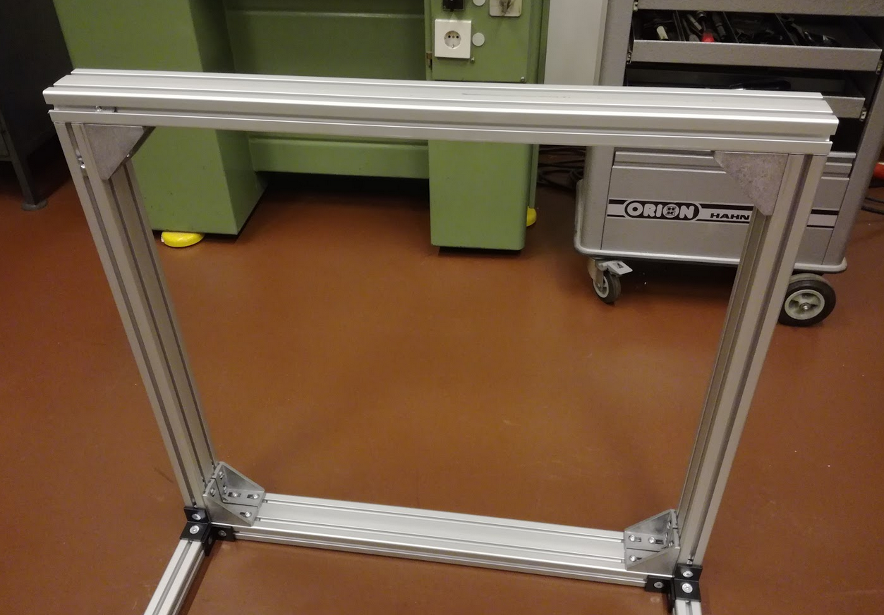Figure 14: Assembled structure after step 4.

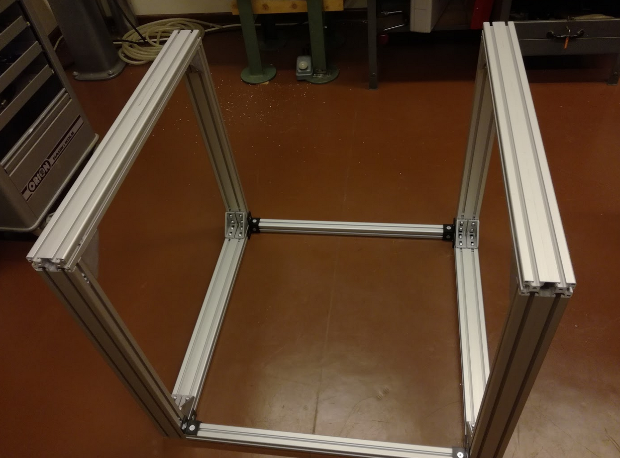Figure 15: Assembled structure after step 4.

- Step
Components needed:
Quantitiy | Part description | Number (BoM) | Comment
1 | Aluminum frames, (40x40x800)mm² | 3
8 | Screws, M8x18, countersunk | 4
4 | Slot nuts, M8 | 4
4 | Angles, 40 | 4

  - Insert the two slot nuts at each end of the aluminum frame (like in step 2).
  - Attach the angles to the aluminum frame and connect it to the remaining structure (Figure 16).

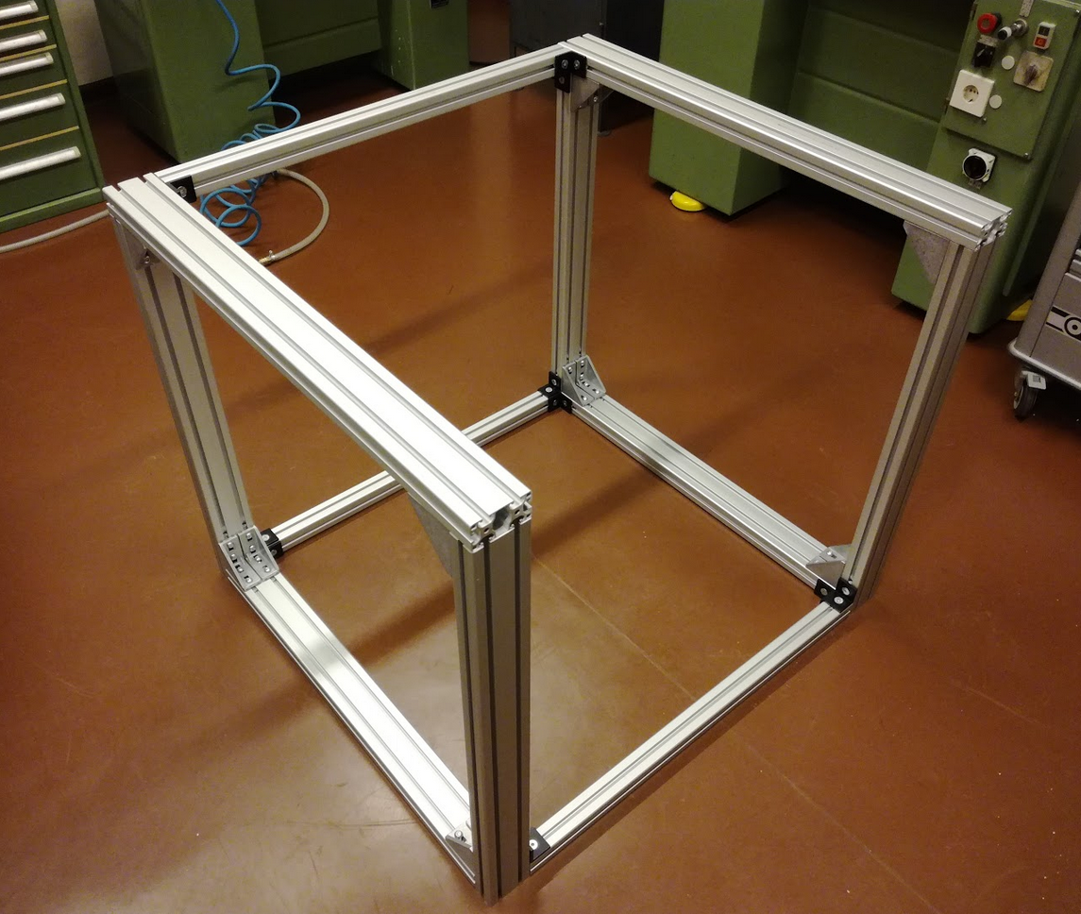Figure 16: Assembled structure after step 5.

- Step
Components needed:
Quantitiy | Part description | Number (BoM) | Comment
10 | Slot nuts, M8 | 5
1 | Aluminum plate 3 | 6 | See CAD file or technical drawing for more information
1 | Aluminum plate 4 | 6 | See CAD file or technical drawing for more information
10 | Screws, M8x20, countersunk | 7

  - Insert 6 slot nuts into the horizontal (x-axis) aluminum frame on top (4 slot nuts on the left and 2 slot nuts on the right). Insert 2 slot nuts into the vertical (y-axis) aluminum frame on the left and 2 slot nuts on the right. You can insert them through the bottom and slide them to the top corner. For reference please see Figure 17 & 18.
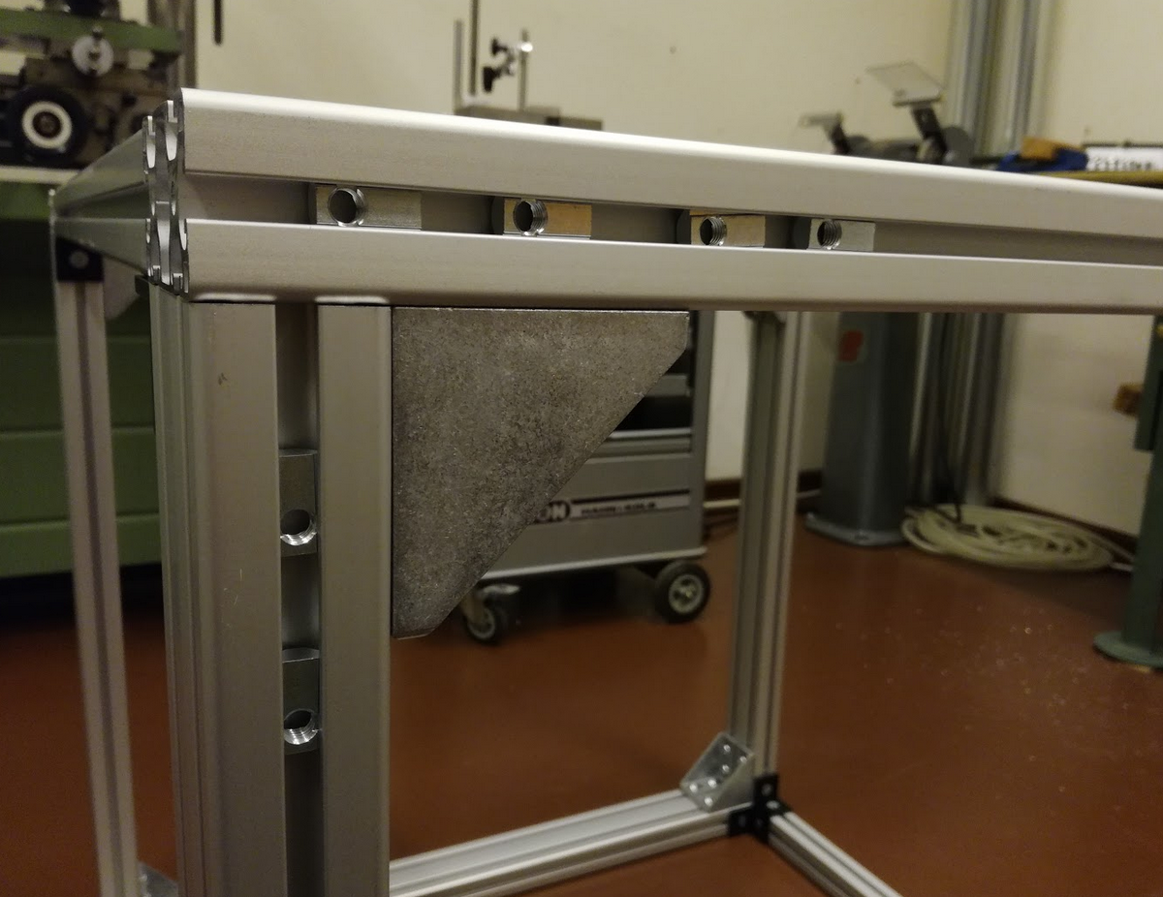Figure 17: “Left” corner with inserted slot nuts
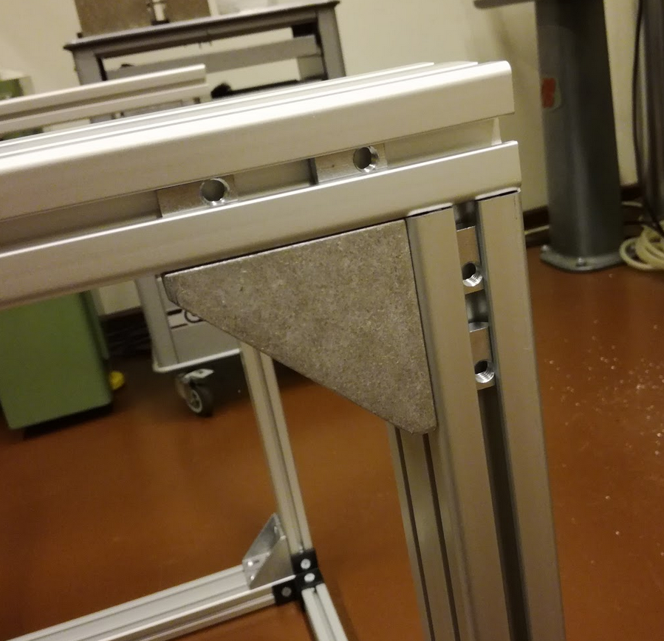Figure 18: “Right” corner with inserted slot nuts

  - Attach plate 3 to the left corner and plate 4 to the right corner of the structure.
- Step
Components needed:
Quantitiy | Part description | Number (BoM) | Comment
24 | Slot nuts, M5 | 8
2 | Supported rail, TBS20 | 9
24 | Screws, M5x20 | 10
4 | Linear bearing, TBR20UU | 11

  - Insert slot nuts on the top two (x-axis) 40x80 frames (2 frames * 2 rails * 6 slot nuts per rail = 24 slot nuts)(Figure 19).
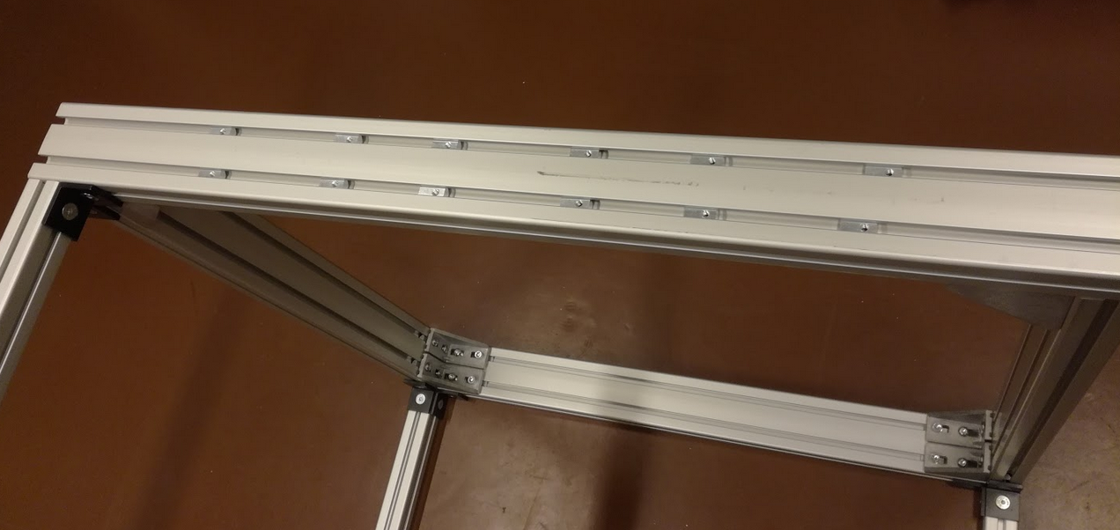Figure 19: Inserted slot nuts at one side of the structure
  - Attach supporting rails to the slot nuts. Important: don’t screw them tight yet.
  - Slide the linear bearings on the supporting rails (Figure 20)

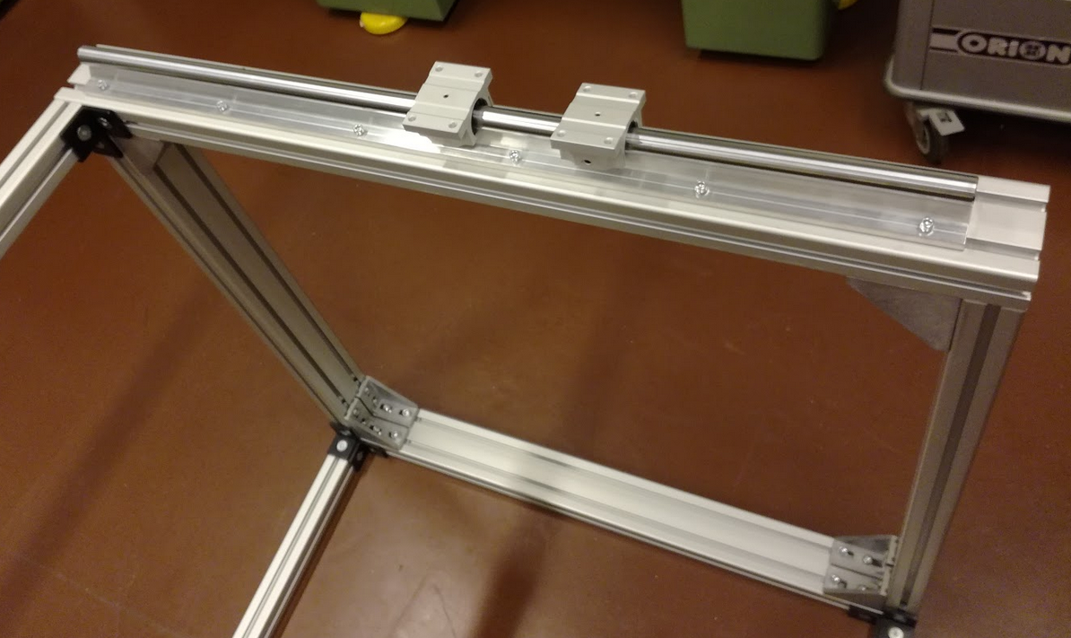Figure 20: Assembled setup after step 7

- Step
Components needed:
Quantitiy | Part description | Number (BoM) | Comment
2 | Ballscrew & spindle nut block | 12
2 | Fixed bearing & motor holder | 13
2 | Floating bearing | 14
2 | Motor coupler | 15
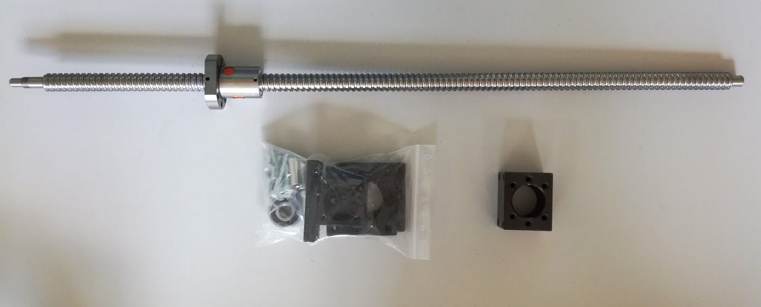Figure 21: Parts to be assembled in this step

  - Attach the motor block (Figure 21, right).
  - Assemble all parts as seen in Figure 22 and Figure 23.
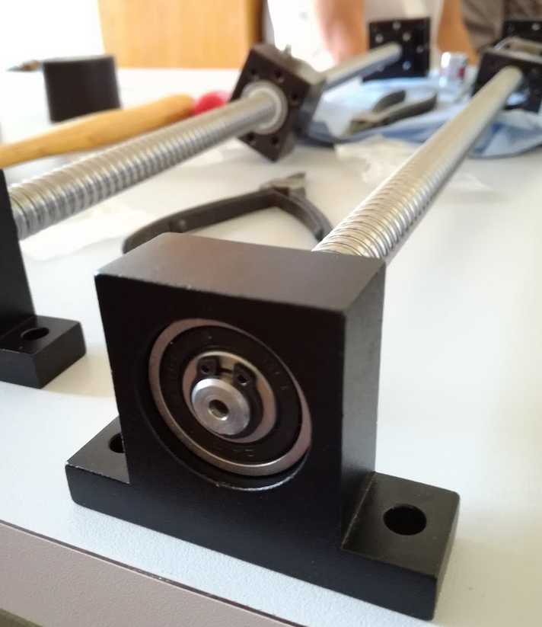Figure 22: Assembled floating bearing
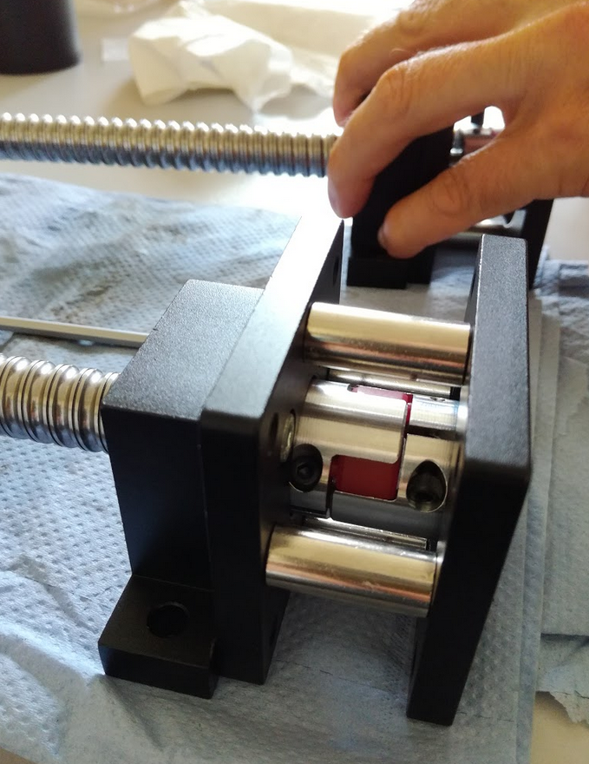Figure23: Assembled fixed bearing, motor holder and motor coupler.

- Step

Components needed:
Quantitiy | Part description | Number (BoM) | Comment
1 | Easy-Mechatronics System | 16
1 | Aluminum plate 8 | 6 | See CAD file or technical drawing for more information
1 | 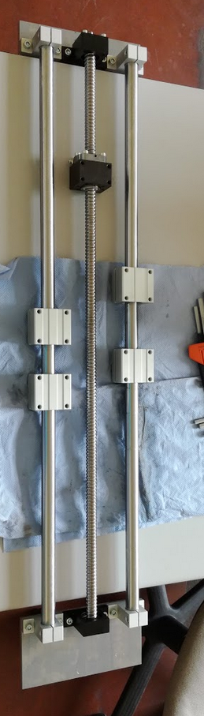  Aluminum plate 9 | 6 | See CAD file or technical drawing for more information
12 | Screws, M6x20 | 17

  - Assemble and attach the Easy-Mechatronics system (z-axis) to aluminum plate 8 & 9 (Figure 24). The motor holder is attached to plate 8.

Figure 24: Assembled bearings of the Easy-Mechatronics system with the aluminum plates 8 & 9.

- Step
Components needed:
Quantitiy | Part description | Number (BoM) | Comment
1 | Aluminum plate 1 | 6 | See CAD file or technical drawing for more information
16 | Screws, M6x20, countersunk | 18
2 | Assembled linear axis (step 8) | - | See step 8 for more infos
8 | Screws, M6x20 | 17

  - Attach plate 1 to the four linear bearings from (Figure 25).
  - Attach one linear axis (y-axis) to plate 1.
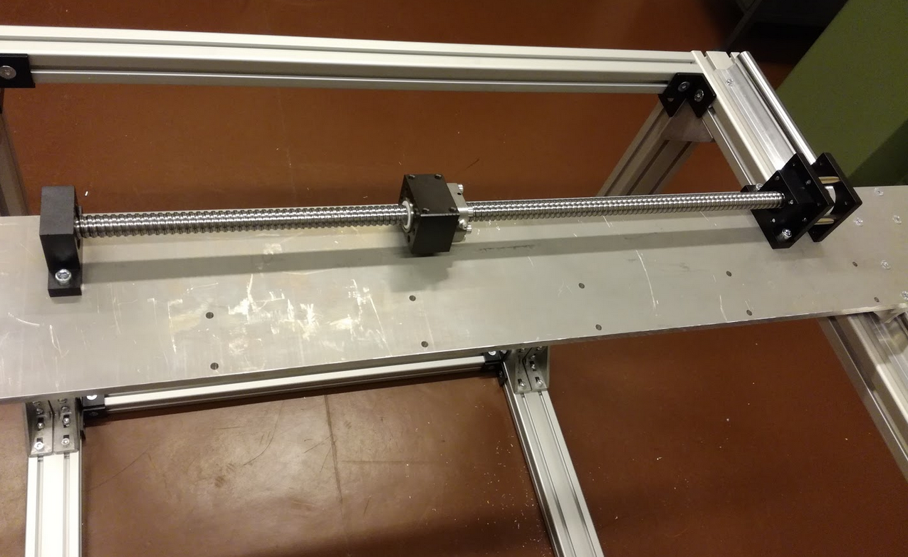Figure 25: Attached linear axis (y-axis) to plate 1.

  - Attach the second linear axis to plate 3 (floating bearing) and plate 4 (motor holder).

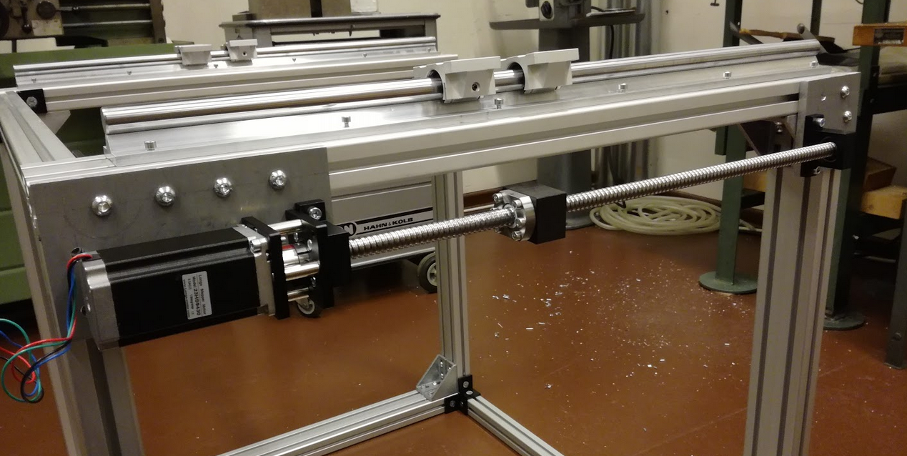Figure 26: Attached linear axis (x-axis) to plate 3 & 4
- Step
Components needed:
Quantitiy | Part description | Number (BoM) | Comment
1 | Aluminum plate 5 | 6 | See CAD file or technical drawing for more information
1 | Aluminum plate 6 | 6 | See CAD file or technical drawing for more information
1 | Aluminum plate 7 | 6 | See CAD file or technical drawing for more information
4 | Screws, M5x30 | 19
16 | Screws, M6x20, countersunk | 18
4 | Screws, M5x20, countersunk | 20

  - Connect plate 5 with plate 6 using the M5x30 screws.
  - Connect plate 6 with plate 7 using the M5x30 screws. The assembled setup should look like in Figure 27.
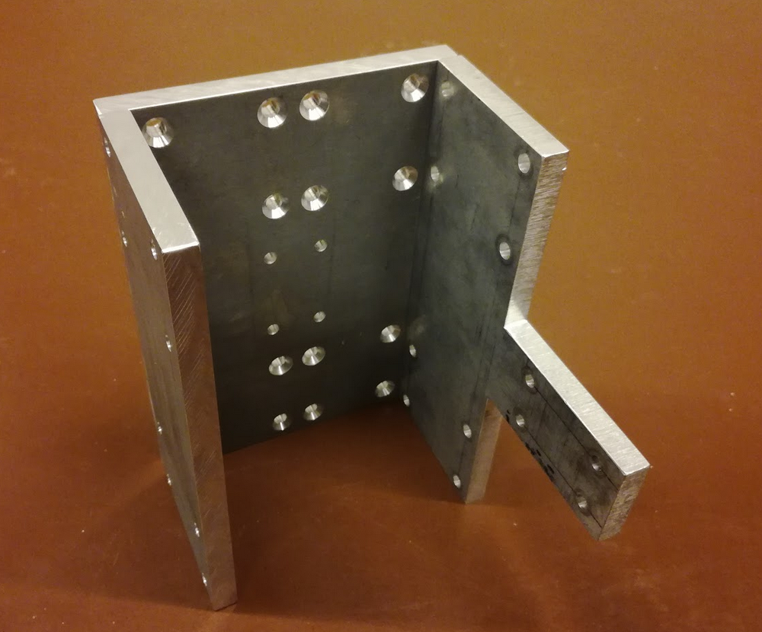Figure 27: Assembled plates 5, 6 and 7
  - Attach plates 5, 6 and 7 using the M6x20 screws to the linear bearings from the Easy-Mechatronics system in step 9 (z-axis). Make sure that the linear bearings are positioned as in Figure 24 (pointing away from plate 8 & 9). Plate 5 should be pointing towards the motor holding block (Figure 28).
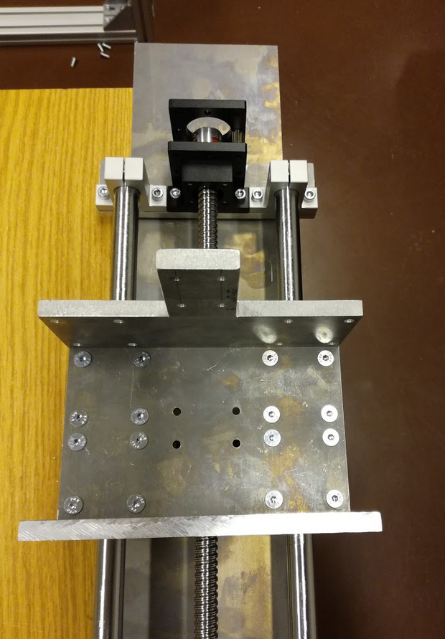Figure 28: Assembled z-axis
  - Fix plate 6 to the ballscrew block using M5x20 screws.

- Step

Components needed:
Quantitiy | Part description | Number (BoM) | Comment
2 | Supporting Rail | 9
4 | Linear bearing | 11
12 | Screws, M5x30 | 19
12 | Hexagon nut, M5 | 21

  - Slide the linear bearings on the supporting rails (2x top, 2x bottom)
  - Place one supporting rail on top of plate 1 and put all 12 screws through the holes. Now place the other supporting rail at the bottom of plate 1, so that the screws go through the holes, and fix the rails with the hexagon nuts (Figure 29).

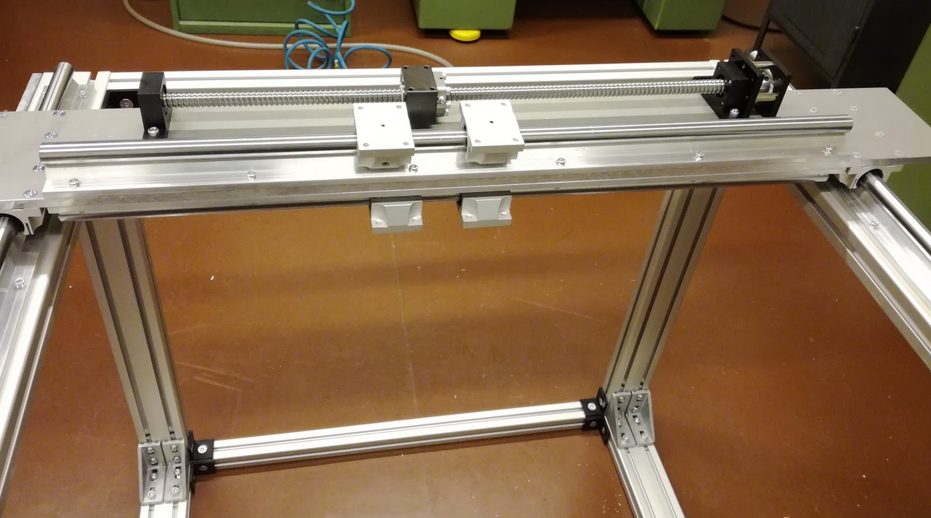Figure 29: Assembled supporting rails and linear bearings
- Step
Components needed:
Quantitiy | Part description | Number (BoM) | Comment
1 | Assembled z-axis (step 11) | - | For more details see step 11
16 | Screws, M6x20, countersunk | 18
4 | Screws, M5x20, countersunk | 20
4 | Distance plates 1mm | 22 | optional

  - Attach the assembled z-axis to the linear bearings from step 12 using the M6 screws (Figure 30). You might need to loosen the screws connecting plate 6 with plate 5 and plate 7 (step 11) a little bit if it is too tight. After assembly you can fix these screws again. It might be easier to start with the top two bearings first and then screw the bottom ones. If there is too much space left, you can use 1mm distance plates between the linear bearings and the plate 5 and/or plate 7 (Figure 31).
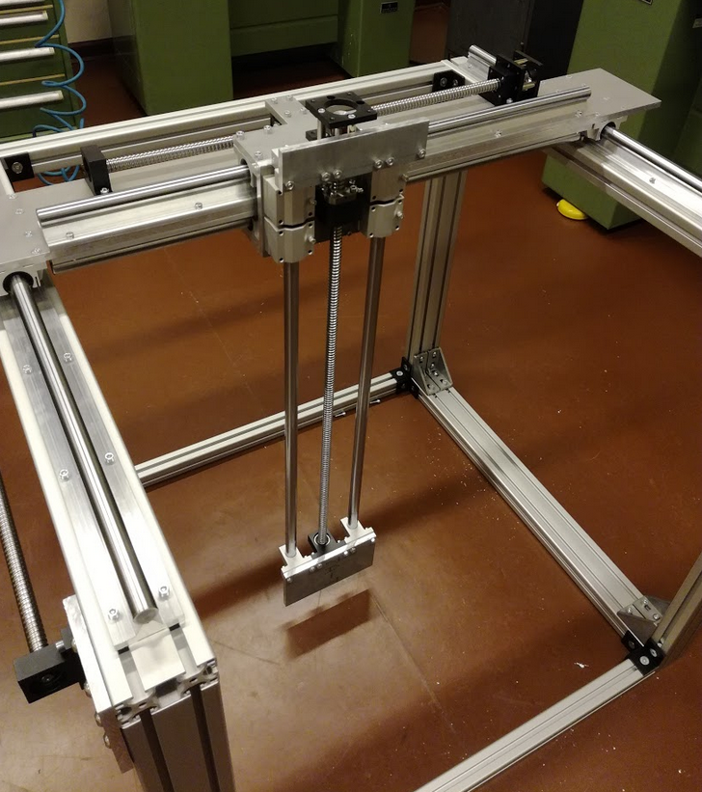Figure 30: Attached linear axis (z-axis) to the linear bearings of the y-axis

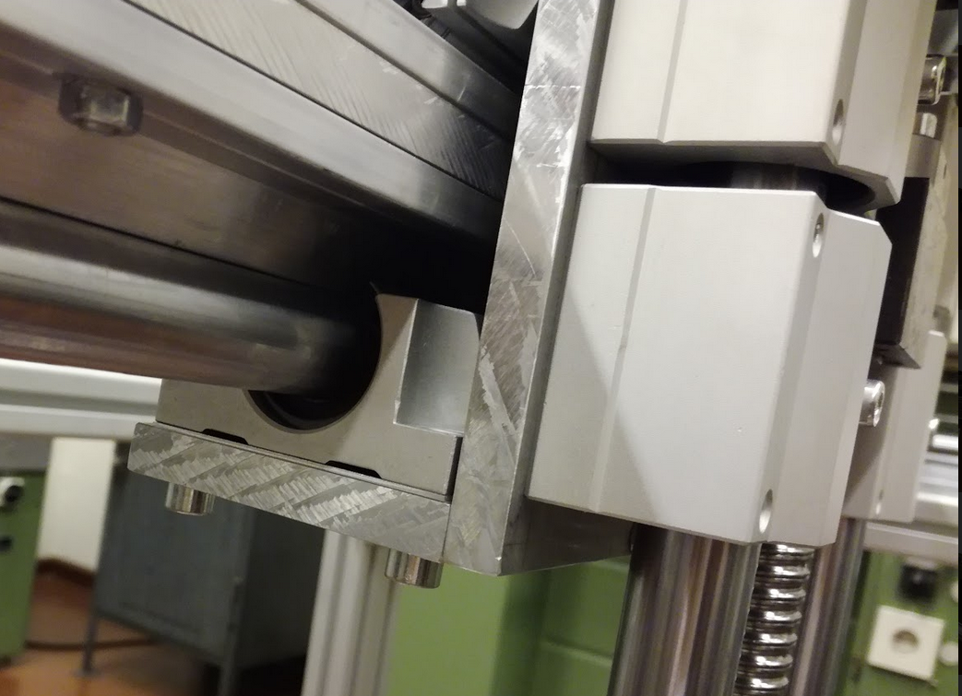Figure 31: Close up of the attached axis. Please note that a distance plate of 1mm thickness has been used at the bottom for an improved fit.

  - Fix plate 5 to the ballscrew block of the y-axis using M5 screws (Figure 32).
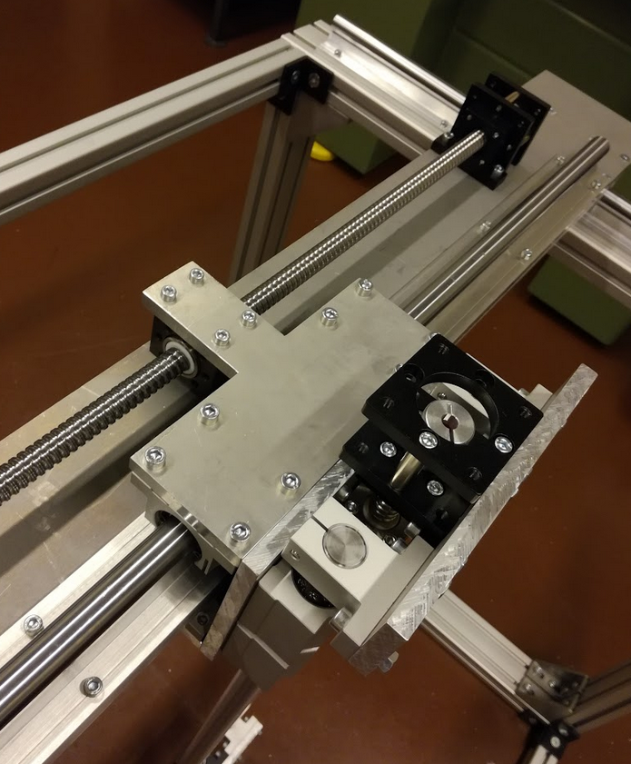Figure 32: X-axis attached (via plate 5) to the linear bearings and the ballscrew of the y-axis.

- Step

Components needed:
Quantitiy | Part description | Number (BoM) | Comment
1 | Aluminum plate 2 | 6 | See CAD file or technical drawing for more information
4 | Screws, M5x30 | 19
4 | Screws, M5x20, countersunk | 20
1 | Distance plate 1mm | 23 | Optional

  - Attach plate 2 to plate 1using the M5x30 screws.
  - Attach plate 2 to the ballscrew block from the x-axis using M5x20 screws (Figure 33). Optionally a distance plate can be included at the ballscrew block.
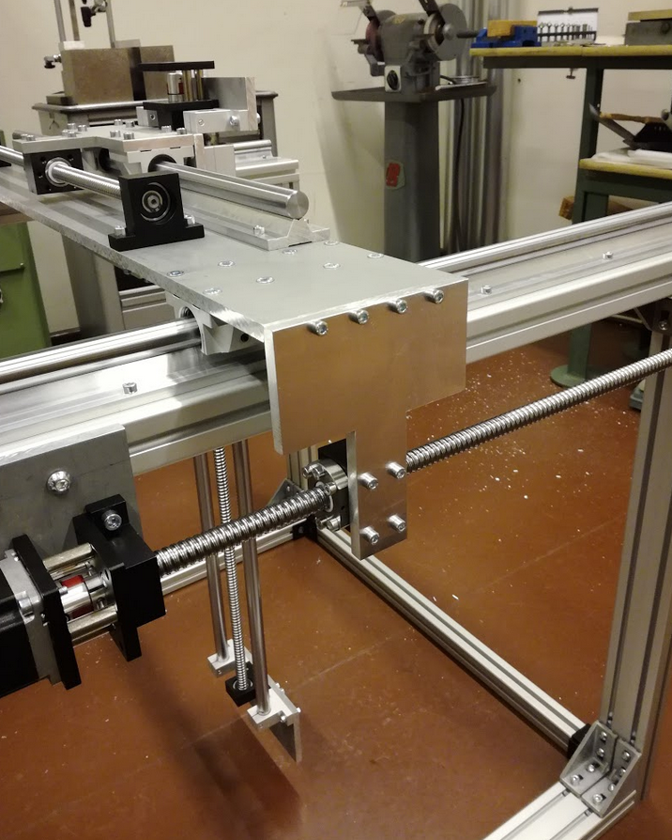Figure 33: Attached plate 2, plate 1 and the ballscrew block from the x-axis.

The assembled configuration should look like in Figure 1 and Figure 34.

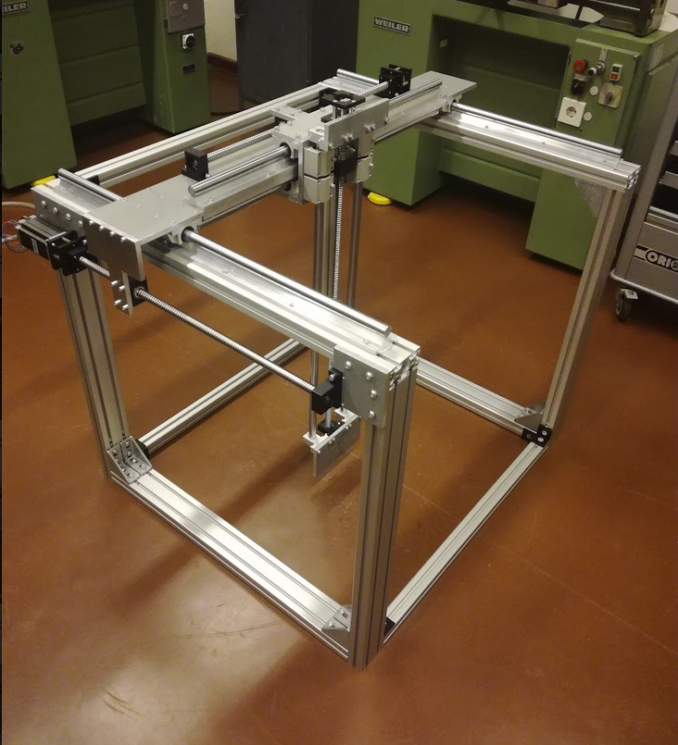Figure 34: Final configuration after following all assembly steps.

Comments

